Transversal Activity: Poster

**Authors:** CoPEH-Canada Team

Connects with:

All Modules

|  |  |  |
| --- | --- | --- |
|  | Unless otherwise stated, the contents of this electronic manual are available under the terms of the [Creative Commons Attribution-NonCommercial 4.0 International License.](https://creativecommons.org/licenses/by-nc/4.0/deed.fr) |  |

**You are authorized to:**

**Share** - Copy, distribute and communicate the material by any means and in any format.

**Adapt** - Remix, transform and create from the material.

**Under the following conditions:**

**Attribution** - You must credit the original author.

**No commercial use** - You may not use the material for commercial purposes.

**To cite this tool** :

CoPEH-Canada (2012) Transversal Activity: Poster. Ecosystem Approaches to Health Teaching Manual*.* [Communauté de pratique canadienne en approches écosystémiques de la santé](https://copeh-canada.org/fr/manuel-d-enseignement.html)

Table of contents

Introduction 2

Pedagogical significance 2

The Poster 2

Key Questions 4

Directions 4

Guiding Questions 5

Poster Activities 5

Creating Posters 5

Interactivity and Integration 6

# Introduction

Transversal activities are an important component of ecohealth courses. They are activities that last for several days and provide an opportunity for participants to return to them at several different moments, bringing new things that they have learned and making adjustments to what they had previously known (or thought they knew). The transversal activities presented here can be used as activities for all of the modules in this teaching manual.

## Pedagogical significance

* Transform student – teacher relations by fostering alternative modes of engagement, feedback and conversation.
* Foster transdisciplinarity by providing a space for participants to make connections between elements of the course which could not have been predicted.
* Act as a device for the creation of experiential continuity throughout the course.
* Break down linear thinking by encouraging multiple forms of expression.

# The Poster

The poster exercise is a transversal activity that evolves throughout the course. It is designed to get participants thinking about how their learning in the course informs their research or practice. The poster helps integrate knowledge by giving participants a concrete point of focus. It also facilitates exchanges of references, methods and ideas amongst course participants (students, instructor, and guests) by providing an accessible platform to share projects. By providing a common template with wide categories, participants from any discipline can describe their projects, enabling participants to access one another’s work from multiple disciplines.

Participants are asked to consider their posters as a way of presenting their projects to others. As the course evolves, they are invited to augment/adapt/change their poster with new ideas, references, methods as sessions spark ideas and as the comments of others are incorporated. Participants use small post-it notes in order to offer comments to the projects of others. It is important for instructors to give feedback and make themselves available for discussion.

The poster activity is designed to:

* Enable participants to share their work with others (especially those from other disciplines)
* Provide a way for participants to contribute to the projects of others and gain feedback on their own work.
* Act as a point of focus to think critically about our projects in the context of ecohealth research or practice.
* Foster dialogue amongst course participants.

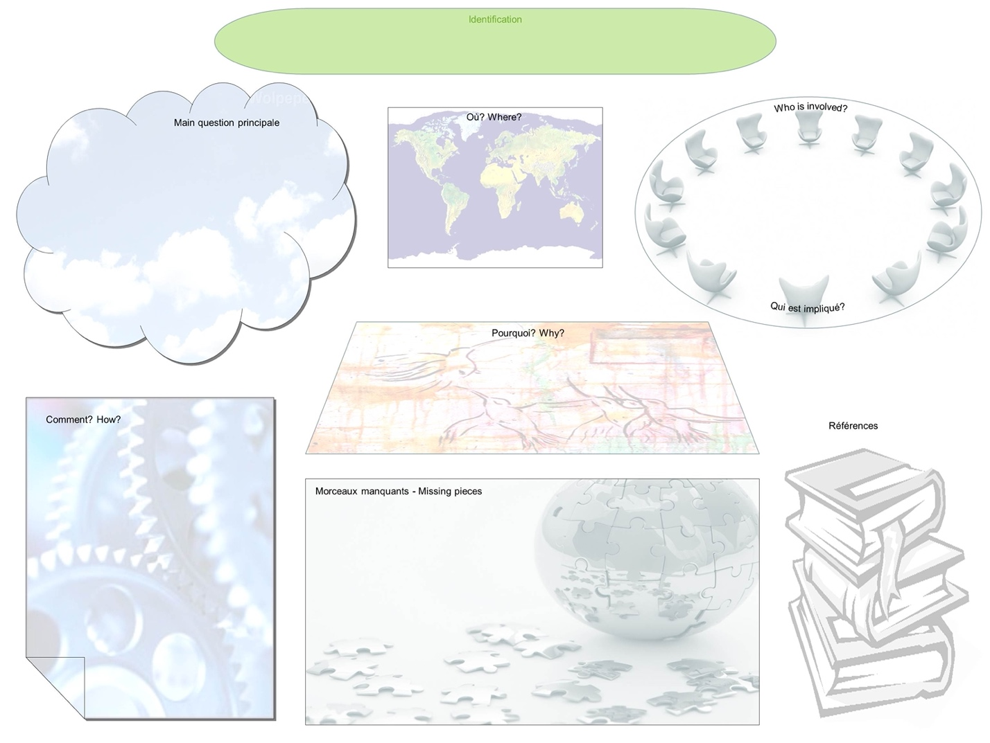

**Figure 1.** Poster Template

## Key Questions

* How is my project being informed by the course content and exchanges with other members of the course?
* What can I share with others to help them with their projects and reflections?

## Directions

At the beginning of the course, participants are given a plasticized erasable “blank” poster board to use in presenting their project with the following categories:

* Project Title
* Main question/Question principale?
* Where?/Où?
* Who is involved?/Qui est impliqué?
* How?/Comment?
* Why?/Pourquoi?
* Missing Pieces/Morceaux manquants
* References/Références

**Note:** *Many of the key questions or discussion questions provided in the different modules of this teaching manual are useful to students and make good questions to place in relation to the individual projects. Instructors can used these to provoke discussions.*

## Guiding Questions

* How is health defined in your project?
* How is gender treated?
* What are the boundaries of your system? Does it matter?
* At what scale are you working?

## Poster Activities

### Creating Posters

**STEP 1.**

Provide time on the first day for participants to create their poster and schedule time for participants to visit one another`s posters.

***STEP 2.***

*Initial first few days (or weeks)* – Have students go back to their posters to integrate lessons learned in a day. A focus can be given to students.

* + for example – How is health defined? What are the power relationships in your project? What actors have you missed?

**STEP 3.**

*After students are more comfortable with the poster exercise* – Create ‘disturbance’ or ‘discomfort’ by imposing some constraints on their projects, or posing a hypothetical problem, for example:

* What if your funding is cut?
* What if a group of actors decided to quit the project?
* What if there is a natural disaster in your study region?

**STEP 4.**

*Wrap-up activity* – the object of this activity is to discuss how the individual projects have changed during the course. For example:

* “speed-discussion” in triad with iterations: Have students pair up and ask one instructor to join each pair to form a triad. Each student then gets a limited time to have a discussion on how his or her project has evolved. After the limited time is up, the discussion changes to the 2nd students project. After this first round, ask student to find a new partner, instructors join a new pair, and repeat.
  + - A good time limit is between 5 and 10 min per student.
    - A good number of iterations: 2 or 3 rounds.
* A wrap-up group discussion is also useful at the end of the ‘speed-discussion’ where this exercise can be debriefed.

### Interactivity and Integration

The poster activity is highly interactive and integrated with other sessions. For instance:

* Concept mapping [[Complexity Module](https://copeh-canada.org/en/teaching-manual/complexity.html)]: When doing a concept map, it is helpful to give students time to go back to their posters. Concept maps can also be hung with the posters as this encourages connections between them.
* Where are health and the ecosystem?: An activity that poses this question has students thinking about how they define and frame health and ecosystem in their project. By giving students time to return to their posters, they can further develop their research question and modes of approach.
* Power and equity: Identifying power relationship in one’s project can help make gender and equity issues more evident.

**Materials and Resources:**

If you are doing the activity online

* Poster template
* Platform for sharing posters (a LMS such as Canvas)

If you are doing the activity in person (physically in a room)

* Laminated erasable posters
* Poster board and material to hang posters (have people around to help students hang their posters)
* Erasable markers (different colors, fine point) and erasers (rubbing alcohol can be used)
* Post-it notes (different colors)

**Logistics:**

**Pre-course:**

* Email poster template to course participants so that they can begin to think about ways of presenting their project.
* Have posters printed and laminated or provide the electronic template.
* Determine where in the classroom and how the posters will be hung or how they will be shared. A place in the main classroom makes it easy for participants to work on their own posters, or browse the others during breaks.
* Schedule time at the beginning of your course to introduce poster activity and for participants to create and hang their poster.
* Schedule other time for poster work throughout the course. This time should be divided in structured and non-structured activities.
* Schedule time for instructors to look at posters.
* Plan an interactive wrap-up activity.

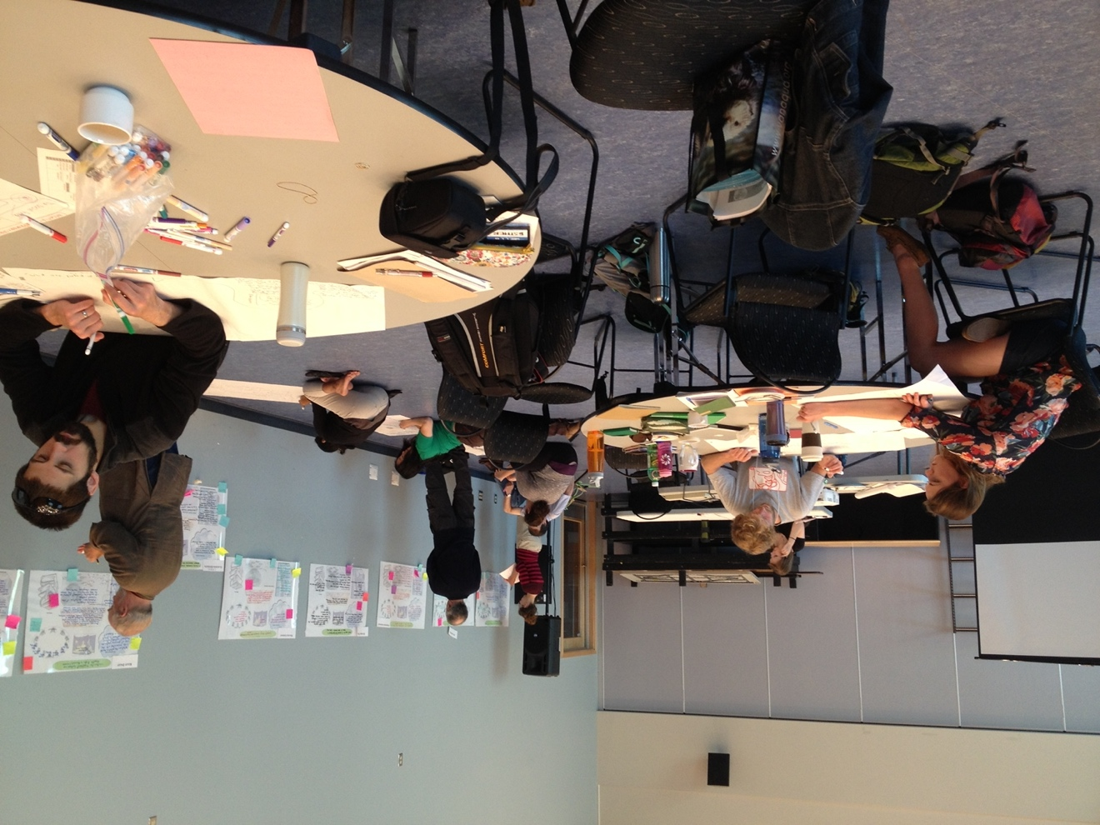

**Figure 2: students working at tables on complexity maps while faculty add sticky notes with suggestions to students’ posters (hung on the walls of the classroom)**